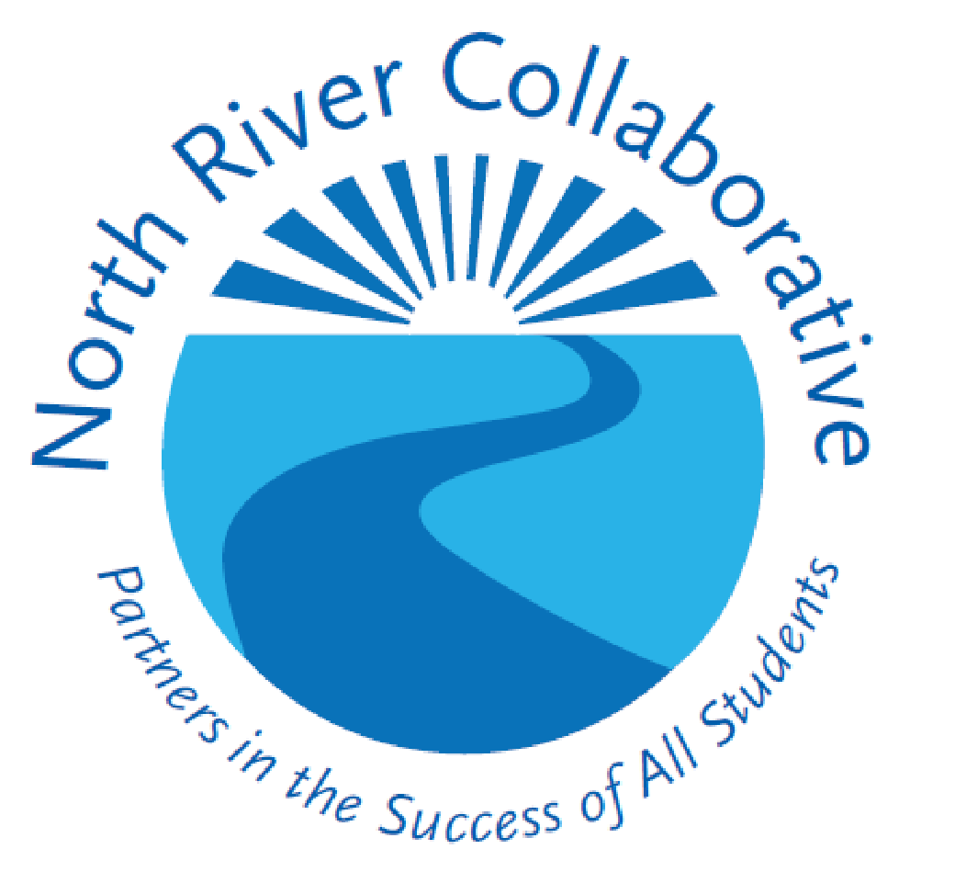

2023
Summer Work and
Learning Program
Student Registration Forms*

*Please return completed forms to District Special Education office for distribution to the Summer Work program. Thank you.
North River Collaborative
Summer Work and Learning Program Overview
2023

The North River Collaborative’s Summer Work and Learning Program offers a broad range of transitional services for students between the ages of 14-21 with intellectual impairments, developmental disabilities, behavioral challenges, and autism. The program is designed for students to attend one or more summers and is differentiated based on students’ transitional needs. The program is located at Abington Middle-Senior High School and local job sites. A broad range of transitional services are integrated with academic support and remediation through hands-on instruction and opportunities for work experiences such as retail, building maintenance, shipping and receiving, office practices and food service.

Students participate daily in a variety of activities offering instruction in life skills for independent living including: Daily Living Skills (managing money; use of common household tools/appliances; time management; personal health and safety; basic meal preparation; leisure/recreation activities; community experiences), Social Thinking Skills, Job Exploration (job training and placement/opportunities, developing/maintaining appropriate work skills and behavior), Health and Fitness for Life and Academic Tutoring related to successful employment.

Based on student interest and availability, students will report to unpaid job sites to explore career interests, gain vocational skills and apply academic skills to real world settings. Students may make community trips and participate in travel training. Students will attend daily meetings with peers and staff members during which they share successes about solving problems at job sites, brainstorm perplexing job site issues and assess personal progress towards attaining work readiness skills. Employment expectations, compensation, and self-advocacy skills are also reviewed. The program utilizes the Massachusetts Work-based Learning Plan to assess student progress toward reaching vocational goals.
PROGRAM INFORMATION 2023
Location Abington Middle-Senior HS  Student Hours: 8:00 am-2:00 pm  Transportation: Provided by your child’s sending district | Week 1 Mon -Thurs July 10-13  Week 2 Mon -Thurs July 17-20  Week 3 Mon -Thurs July 24-27  Week 4 Mon -Thurs July 31-August 3  Week 5 Mon -Thurs August 7-10  NO PROGRAM on FRIDAYS

I would like my child to participate in North River Collaborative’s Summer Work and Learning Program.

Student’s Name Parent Signature
Job Type Preferences For Students
This information will help us in designing groups to address specific skills.
Please mark your preference for future job types: 1 = first, 2 = second, 3 = third
_____ Retail _____ Building Maintenance _____ Shipping and Receiving
_____ Food services (ServSafe certification training available) _____ Office Practices
I understand job site placements are unpaid.
North River Collaborative
SUMMER WORK and LEARNING PROGRAM
MEDICAL/EMERGENCY INFORMATION

Student’s Name: ______________________________ Date of Birth: __________________

Street Address: __________________________________________Town:___________________Zip Code:________

Zip Code: _________ School Currently Attending: ________________________________________________

IN CASE OF EMERGENCY, YOU WOULD LIKE US TO CALL:

Parent/Guardian 1: ______________________________________________________________________ Name Address Phone

Parent/Guardian 2: ______________________________________________________________________
Name Address Phone

List two neighbors or nearby relatives who will assume temporary care of your child including picking up at school if you cannot be reached.
______________________________________________________________________
Name address phone

_____________________________________________________________________
Name address phone

In case of an accident or serious illness, I request that the school contact me. If unable to reach me, I authorize you to call the physician indicated below and to follow his/her instruction. If it is impossible to contact this physician, in an emergency, I give permission for my child to be treated by any licensed medical practitioner(s).

_______________________________________________________________________
Parent/guardian signature Date Email address

Physician’s Name: __________________________Office Phone: ___________________

Address: ________________________________________________________________

~ MEDICAL INFORMATION ~
Does your son or daughter have any medical problem that we should be aware of? (For example, allergies to bee stings) ❒ Yes ❒ No
If yes, please describe:

List medications and dosage:

Is your son/daughter on any medication that:
- Could impair his/her handling of equipment? ❒ Yes ❒ No b) Is taken during the day? ❒ Yes ❒ No

Medication must be sent in original prescription bottle. *If medication is taken during the Program, a note from a physician is required. Tylenol may not be given without a note from parent/guardian on file.
I give permission for my son/daughter to be given Tylenol ❒ Yes ❒ No
I give permission for my son/daughter to be given Advil ❒ Yes ❒ No

To ensure protection to all workers, tetanus should be up to date. Date of last Tb immunization? ______________

